GEDRAA

Astrophysical Analysis generated automatically by AstrofísicaGEDRAA software tool

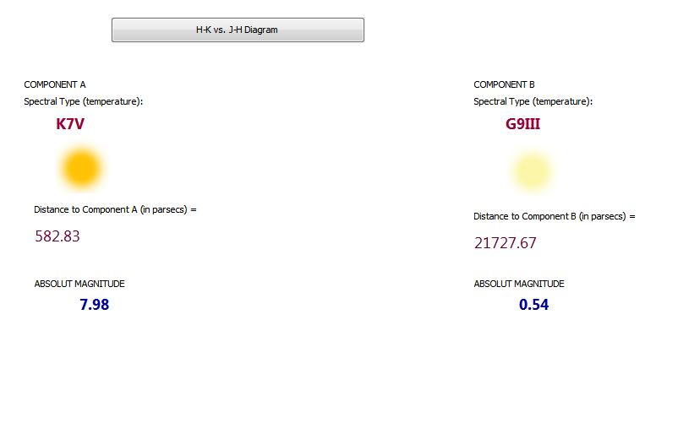

# ASTROPHYSICAL ANALYSIS OF STAR A: 2MASS 762662-7363663

### Visual Magnitude:

16.8077

### J Magnitude:

14.0

### H Magnitude:

14.0

### K Magnitude:

13.0

### B-V Color Index:

1.2661

### V-I Color Index:

1.6376

### V-J Color Index:

2.8077

### ABSOLUTE Magnitude :

7.98

### Galactic Latitude:

44.0

### Bolometric Correction:

0.752

### Distance in Parsecs:

582.83

### Corrected Distance because galactic extinction (de-reddening) (if apply):

0.0

### Color Excess E(B-V) (if apply):

### Extinction Correction (Av):

0.0

### Spectral Type:

K7V

### Proper Motions in RA:

1.0

### Proper Motions in DEC:

1.0

### Total Proper Motions:

1.4142135623730951

### REDUCED Proper Motions:

-33.540567951399865

# ASTROPHYSICAL ANALYSIS OF STAR B: 2MASS 762662-7311111

### Visual Magnitude:

17.2250656

### J Magnitude:

15.0

### H Magnitude:

15.0

### K Magnitude:

14.2

### B-V Color Index:

1.017979200000001

### V-I Color Index:

1.287456000000001

### V-J Color Index:

2.225065600000002

### ABSOLUTE Magnitude :

0.54

### Galactic Latitude:

44.0

### Bolometric Correction:

0.382

### Distance in Parsecs:

21727.67

### Corrected Distance because galactic extinction (de-reddening) (if apply):

0.0

### Color Excess E(B-V) (if apply):

### Extinction Correction (Av):

0.0

### Spectral Type:

G9III

### Proper Motions in RA:

1.0

### Proper Motions in DEC:

1.0

### Total Proper Motions:

1.4142135623730951

### REDUCED Proper Motions:

-33.95793355139986